Bridging the Digital Divide in Africa: Access, Empowerment, and Equality
Photographic Essay by Faith Chebet

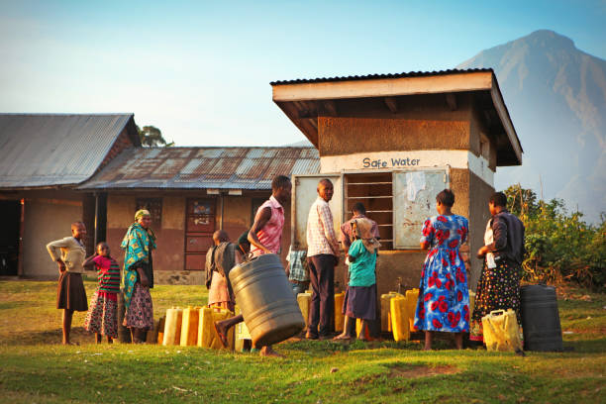
African communities
In many African communities, access to technology, water, roads and medication remains a privilege, not a right.
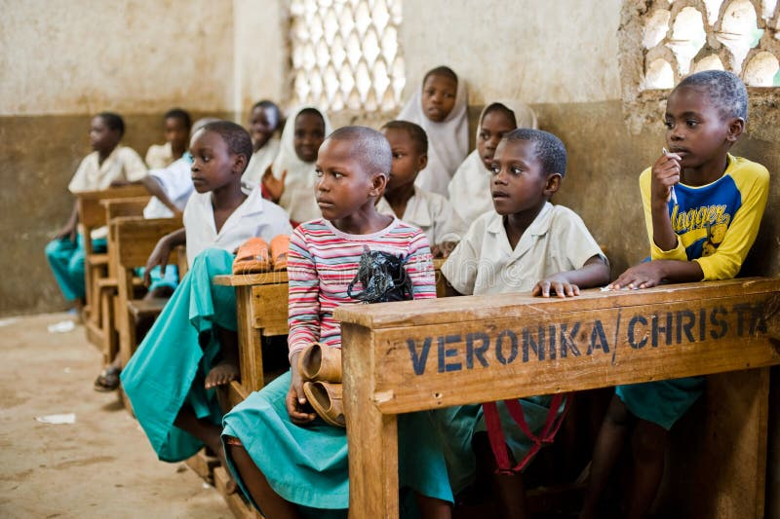

Rural School
In rural schools, students share a desk and books for learning yet their curiosity and potential shine through.
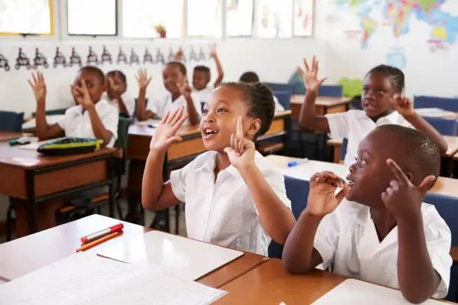

Modern schools

In contrast, urban centers students have their specific allocated sits and also the get good books.

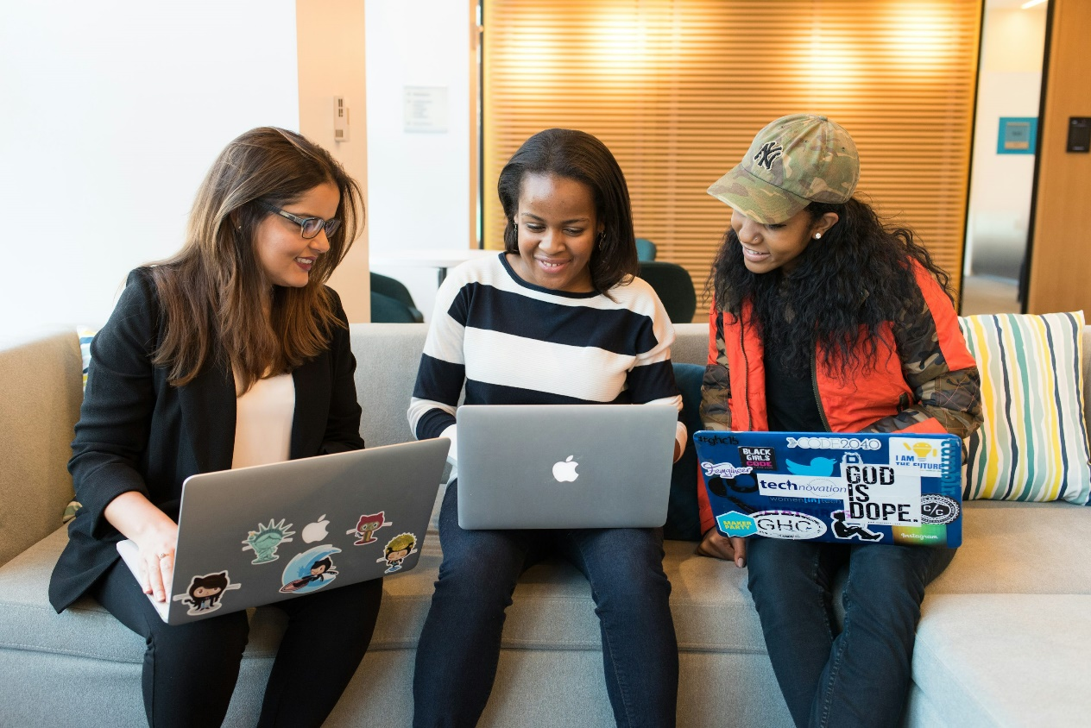
Women in Tech
Empowering women in technology creates stronger, inclusive communities.
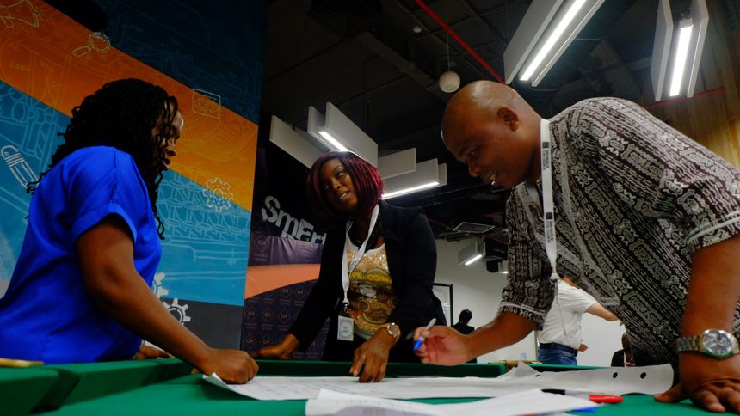
The Power of Innovation
Young African innovators are finding creative ways to bring internet access to remote areas.



The Human Connection

Technology is not just about machines; it’s about connecting people and giving everyone a access to things in the world.

